Template – Enrollment Agreement
The template named “Template – Enrollment Agreement” is applicable to Anthology Student.

Purpose and Outcome
This template provides a form sequence and supporting workflow for an enrollment agreement to be submitted by an applicant. The sequence requires the following:
- A complete Applicant Record must exist in the Anthology Student database (any missing field, e.g., Grade level, could cause a failure in the workflow). In our example, we are using the “Pending Applicant” status.
- The applicant must have a Portal login to log into this authenticated sequence.
The template includes the steps required to collect DocuSign signatures/initials from the applicant and from a staff member.
Upon completion of the sequence, the student’s Applicant Record is converted to an Enrollment and the signed enrollment agreement (PDF) is added to the student’s document list in CampusNexus Student.

Prerequisites
The template was built in Forms Builder using the applications listed below. The template is forward compatible with later versions of the listed applications.
Application | Compatibility Version
Forms Builder Designer and Renderer | Compatibility Matrix
Web Client for Anthology Student
Workflow Composer
Packages installed from Package Manager in Workflow Composer | Activities and Contracts (V2)  Contracts (V1)  Forms Builder Contracts  Note: Ensure that the Forms Builder Contracts package used in Workflow Composer is aligned with the version used in the Forms Builder. Additionally, confirm that both Activities and Contracts (V1) and Activities and Contracts (V2) packages in Workflow Composer match the versions used in the Student Web Client to avoid compatibility issues.  It depends on which product is being used, for example:  For CRM:  Activities And Contracts (CRM)  Forms Builder Contracts
Workflow Tracking Database | N/A
Staff STS | 3.3.x

Step 1: Download and Import the Template
- Download the template file to your environment (local drive or network location).
- Log into Forms Builder Designer.
- Click the Export/Import tile.
- Select the Import tab.
- Click Select exported file and navigate to the downloaded template file.
- Click Import.
Note: Import may fail if same files name is already available in environment or overwrite option.
- Export/Import

The following forms will be imported:

WelcomeNew

Campus University - Enrollment Agreement

Campus University - Enrollment Agreement Acknowledgements

Default-Frame

DocuSignWait

Custom - Confirmation

Step 2: In Form Designer…
- From the Forms slide out, select Campus University – Enrollment Agreement.
- Customize the form for your environment. Modify properties on current fields to make them required, etc., or add/remove fields on form. Make sure you edit the text in the Labels and HTML controls as applicable for your institution.
- Fields and Components
- Save the form.
- From the Forms slide out, select Campus University – Enrollment Agreement Acknowledgements.
- Customize the form for your environment and save it.

Step 3: In Sequence Designer…
- Select Campus University – Enrollment Agreement.
The sequence contains the following forms:
- Campus University – Enrollment Agreement
- Campus University – Enrollment Agreement Acknowledgements
- Default Frame (This form is required when DocuSign is used for electronic signatures.)
- DocuSignWait (This form is required in sequences with multiple DocuSign signers.)
- Click Save As to create a copy of the sequence/workflow and customize the copy for your use. This way you can always refer to the original sequence/workflow you downloaded.
- Optional - Add a custom style (theme) associated with your campus.
- Themes
- Select your sequence in the Sequences pane.
- In the Properties Pane:
  - Ensure that the Authentication Product is Student.
- Select the End State Form named Custom - Confirmation.
- Save the sequence.
- Open the associated sequence workflow.
Depending on your environment, to open Workflow Composer either click Open Workflow in Sequence Designer or launch of a local installation of Workflow Composer.
- Opening Workflows for Sequences

Step 4 In Workflow Composer…
- In the Welcome form/state, locate the LookupReferenceItem activity.
Verify that a Reference Item for Enrollment Agreement is found in your environment.
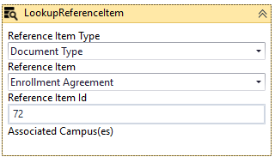
- LookupReferenceItem activity

- In the Default-Frame form/state, locate the Assign Signer 2 Name activity.
In the Value field, specify the name of the staff member that will be signing the enrollment agreements.
- In the Default-Frame form/state, locate the Assign Signer 2 Email activity.
In the Value field, specify the email address of the staff member that will be signing the enrollment agreements.
- In the final transition (labeled “Done”), in the Condition field, add the statement signer2Complete. This statement is excluded from the template to make it easier to test the sequence without having to wait for all signers to complete the DocuSign steps.
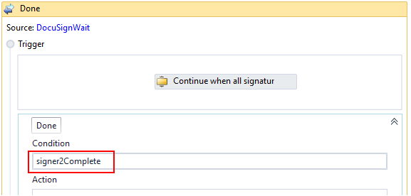

- The final transition contains an If activity that checks if an enrollment agreement was found or created. Locate in the If activity below the GetSignedDocument activity.
Make sure that the document Status property has the same value in both branches (Then/Else) of the If activity.
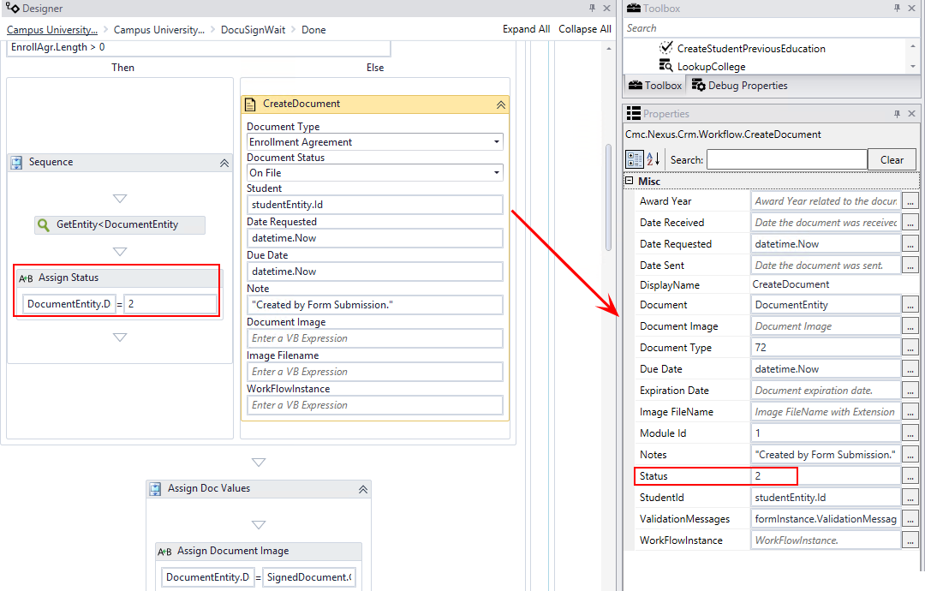

- In the final transition, locate the LookupReferenceItem activity.
In the Reference Item Type field, select the School Status to be assigned after the ConvertApplicantToEnrollment activity is completed.
- In the final transition, locate the ConvertApplicantToEnrollment activity.
In the AcademicAdvisorId field, specify the ID appropriate for your environment.
Note: The Academic Advisor ID in the template is hardcoded and must be updated.
If you are using Activities and Contracts for Anthology Student 19.0 (and later) and the user’s Academic Advisor has been assigned to the applicant, you can add the LookupAdvisor activity followed by an Assign activity to the workflow instead of hardcoding the AcademicAdvisorID value.
- LookupAdvisor activity

Step 5: In Forms Renderer and CampusNexus Student…
Select your sequence and try it out!
- Sequence List
- Find your Enrollment Agreement sequence and copy the URL to the clipboard.
- Log in to Portal as the student and complete the enrollment agreement sequence.
- Verify that the staff member responsible for signing enrollment agreements received the email notification to complete the DocuSign steps.
- In Anthology Student, verify the following:
- The enrollment agreement was added to the applicant’s document list and the PDF is viewable.
- The applicant’s status was updated.
- The applicant was enrolled in the selected program.

Step 6: Lastly…
Once your updated sequence has been tested successfully, it is recommended that you disable the workflow for the original Template version.
- In Workflow Composer, in the Server section of the ribbon, click Open.
- Find the workflow named Campus University – Enrollment Agreement.
- Clear the Enabled check box and click Save.

